

# Practices for Secure Software Report

Table of Contents

Document Revision History 3

Client 3

Developer 4

1. Algorithm Cipher 4

2. Certificate Generation 5

3. Deploy Cipher 8

4. Secure Communications 9

5. Secondary Testing 10

6. Functional Testing 20

7. Summary 23

8. Industry Standard Best Practices 24

## Document Revision History

| **Version** | **Date** | **Author** | **Comments** |
| --- | --- | --- | --- |
| **1.0** | **6-23-2024** | **Alex Baires** |  |

## Client



## Developer

Alex Baires

## Algorithm Cipher

As a growing financial institution, Artemis Financial is responsible for safeguarding consumer information and communication. While the industry standard is SHA-256, I recommend future-proofing Artemis Financials’ software using the SHA-3-384 algorithm.

**History and Current State of Encryption Algorithms**

In 2017, SHA-1 was officially cracked through a collision attack by Google researchers, negating the cipher’s security. The NIST had already recommended switching to the newer SHA-2 family, and the attack completed this process. Unfortunately, Grimes (2018) writes that it is only a matter of time before SHA-256 is cracked because several attacks have whittled down SHA-2’s effective protection to 2^37 computational operations (initially, it would take 2^128 operations to find a collision). SHA-2 utilizes an algorithm similar to SHA-1 but with the same cryptographic flaws. Its saving grace is its more considerable hash length (Grimes, 2018). However, an experiment conducted by Huang et al. (2022) shows that a practical collision attack on a 4-round modification of SHA-3-384 using a deduce-and-sieve algorithm is practical and results in a near-collision by only 4 bits. A well-funded adversary with more computing power may be able to find a collision for this particular reduced-round version (Huang et al., 2022). However, this does not lessen the security of the full 24-round SHA-3-384, as the data goes through another 20 rounds of permutation before becoming a hash value.

**Cryptography**

A cipher algorithm converts plain text into illegible cipher text. A key lets one decode the ciphertext into the original plaintext. A symmetric key algorithm utilizes one shared key to encrypt or decrypt the cipher text. An asymmetric key has two keys: a private and a public key. The private key is kept secret, while the public key is shared. Any data encrypted by one key can only be decrypted by the other. The SHA-3-384 algorithm is neither asymmetric nor symmetric. It is considered a one-way hash function that takes a variable-sized input and generates a fixed-length output or digest. The benefit of a one-way hash function is that any modification to the input results in a modified hash ciphertext. If one finds the cipher text, working backward to retrieve the original plaintext data is impossible (*Cryptography Concepts,* 2024).

Random numbers are essential in cryptography because they generate the keys used by any cryptographic algorithm cipher. Without this randomness, keys are easily predictable and conducive to being broken by attackers. Entropy is the amount of chaos in a system, and a secure system strives for plenty of entropy when generating a random number seed (Sidhpurwala, 2019). A paper written by the SHA-3-384 creators states that other “sponge” algorithms in the Keccak family with smaller lengths can be used as a CPRNG.

**SHA-3-384 Overview**

SHA-3-384 is the next-generation secure hash algorithm released by NIST on August 5, 2015. Its hash function is referred to as a “sponge function” and has absorption and squeeze phases. During the absorption phase, input data is divided into 832-bit blocks and checked, and any small remainder blocks are padded to a size that is the multiple of SHA-3's rate. In our case, this would be a multiple of 832. After this, several permutations occur that generate a message digest of 384 bits. Unlike past SHA algorithms, SHA-3-384 is based on the Keccak algorithm and is mathematically and cryptographically different than previous designs (Akiya et al., 2021; Anand, 2019; Grimes, 2018).

## Certificate Generation

Artemis.cer generated:

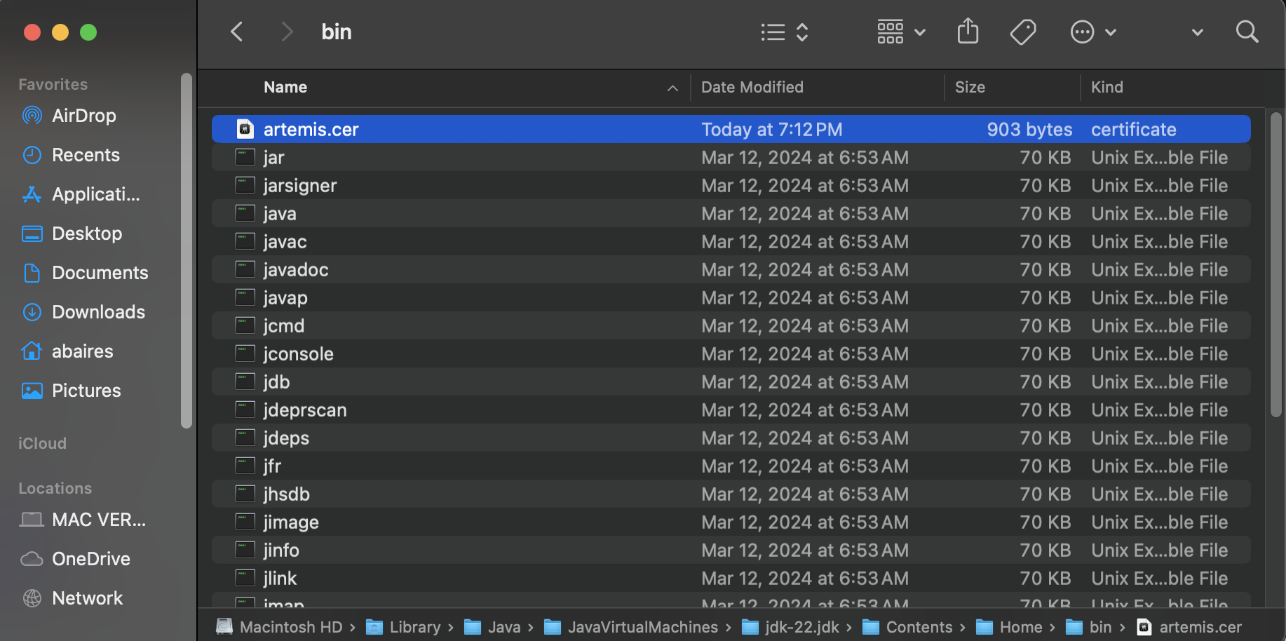

Artemis.cer printout:

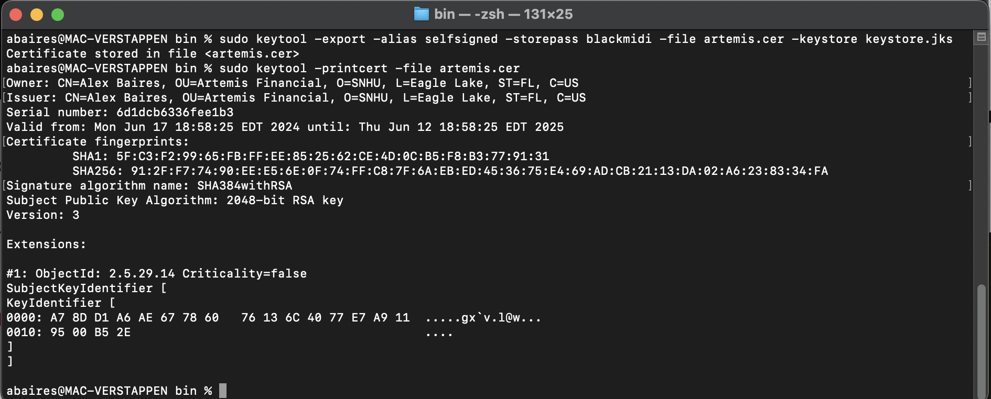

Artemis.cer in macOS Keychain Access (for verification):

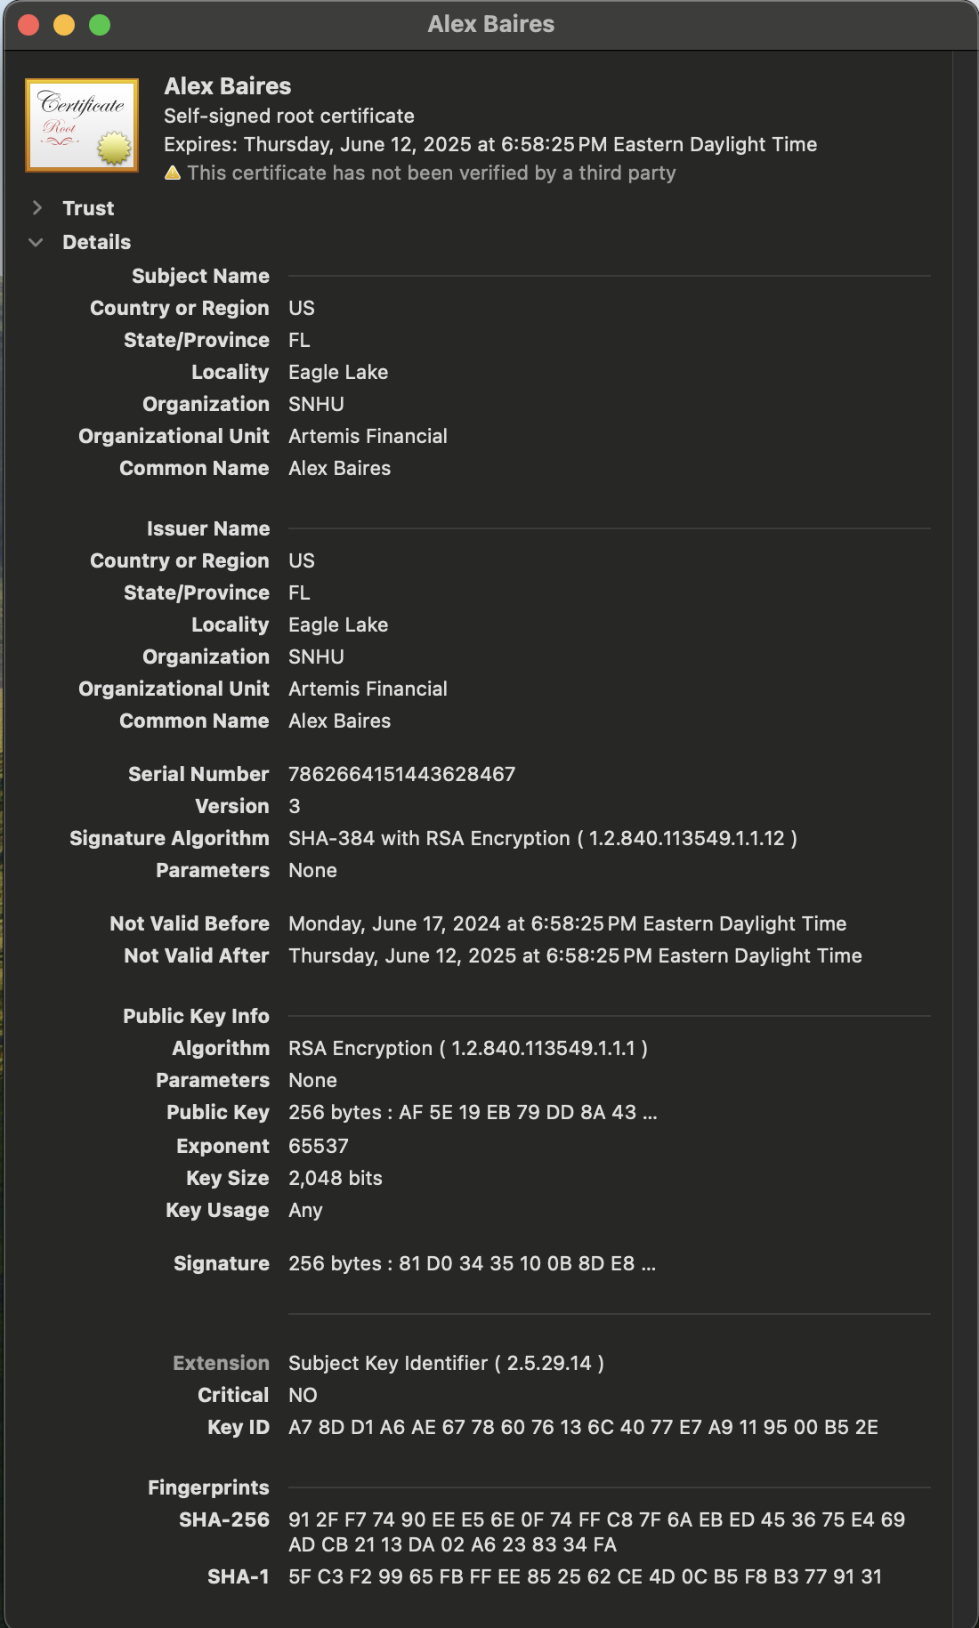

Updated Application.properties with new self-signed certificate placed in Resources:

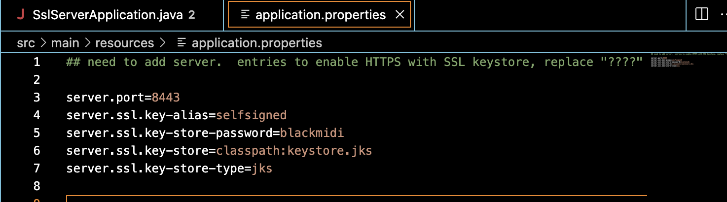

**Viewing Self-Signed Certificate when Connecting to LocalHost in Safari:**

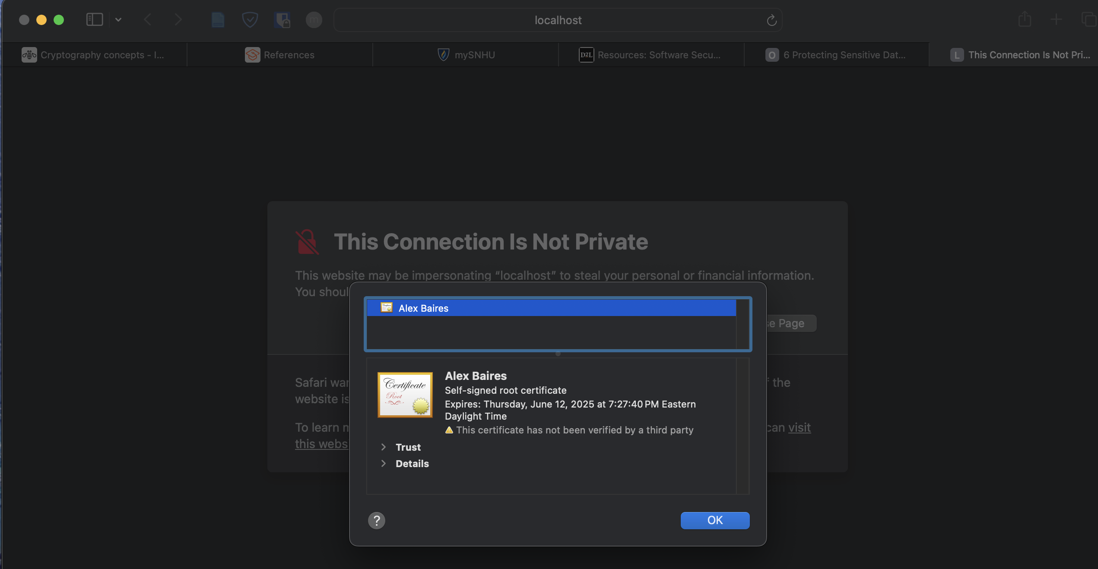

## Deploy Cipher

**Initial Cipher Code Implementation:**

bytesToHex()

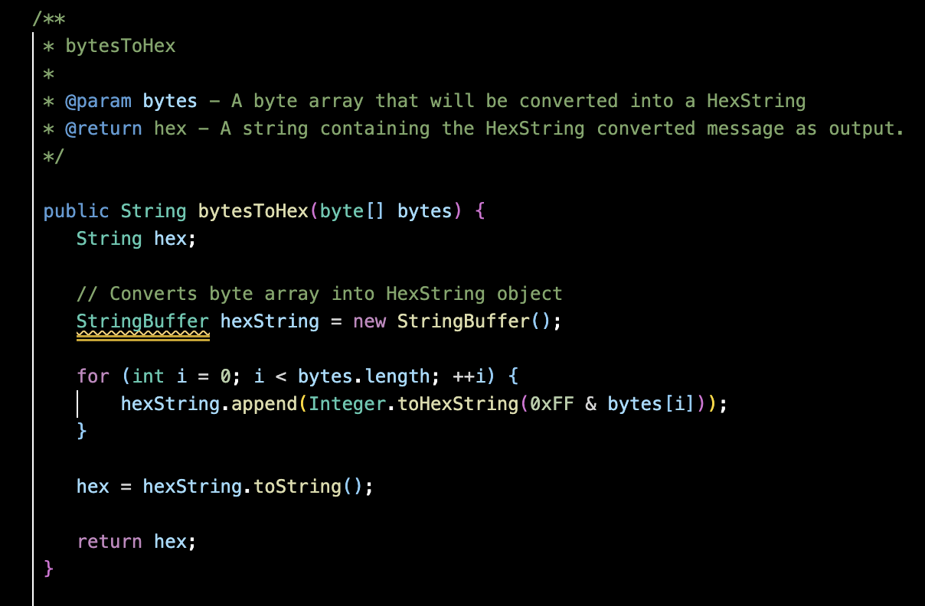

generateCheckSum()

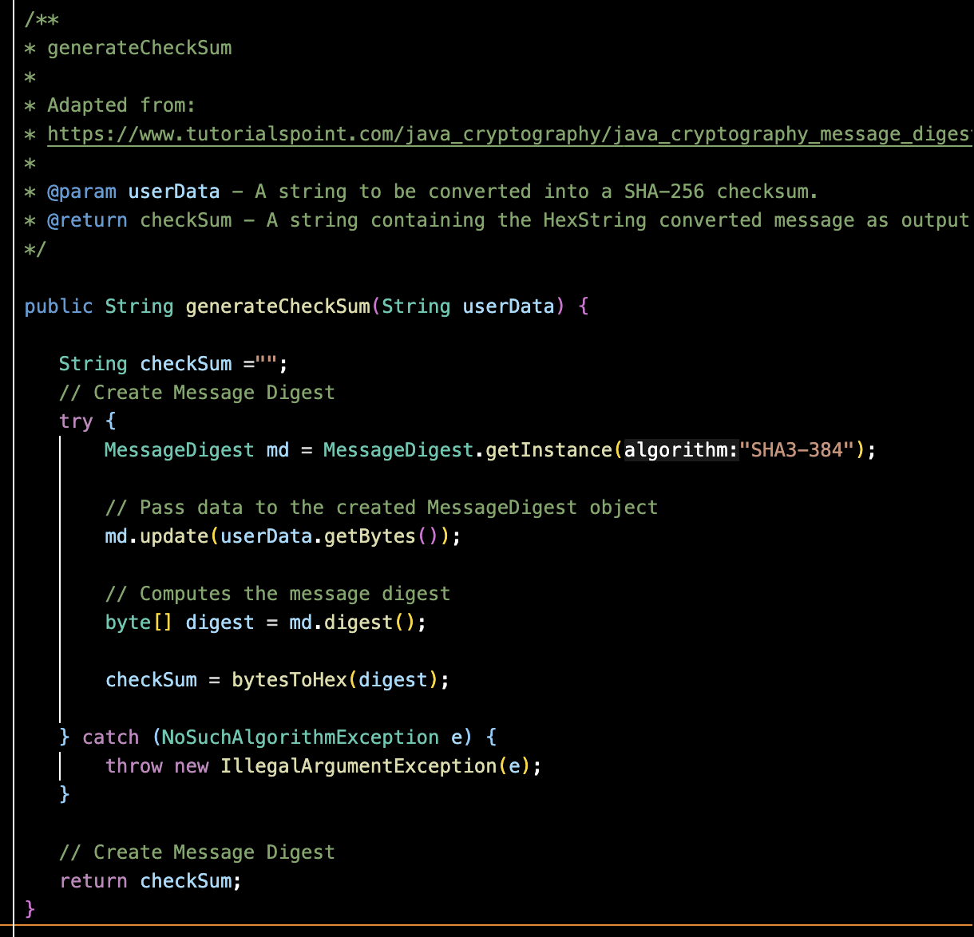

**Static Data String with Converted Checksum Value in Browser:**

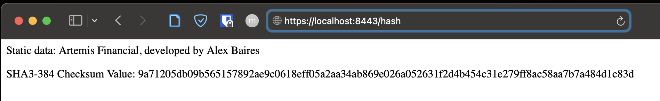

## Secure Communications

Insert a screenshot below of the web browser that shows a secure webpage.



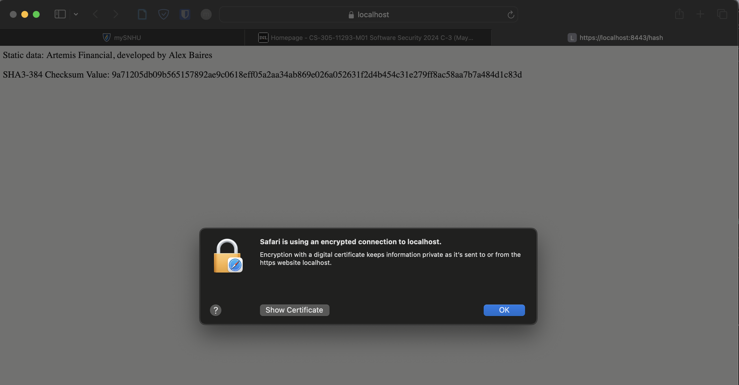

## Secondary Testing

Insert screenshots below of the refactored code executed without errors and the dependency-check report.

Refactored SslServerApplication.java:

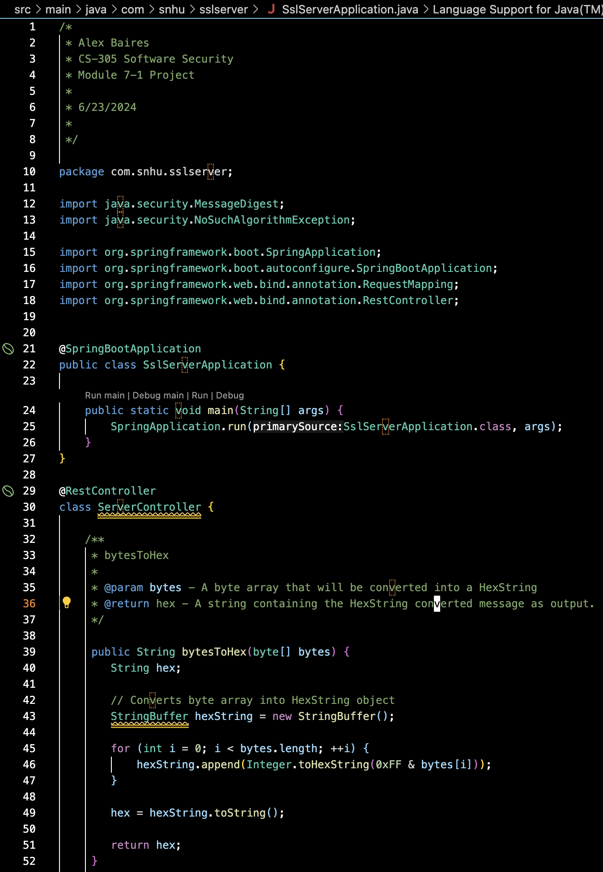

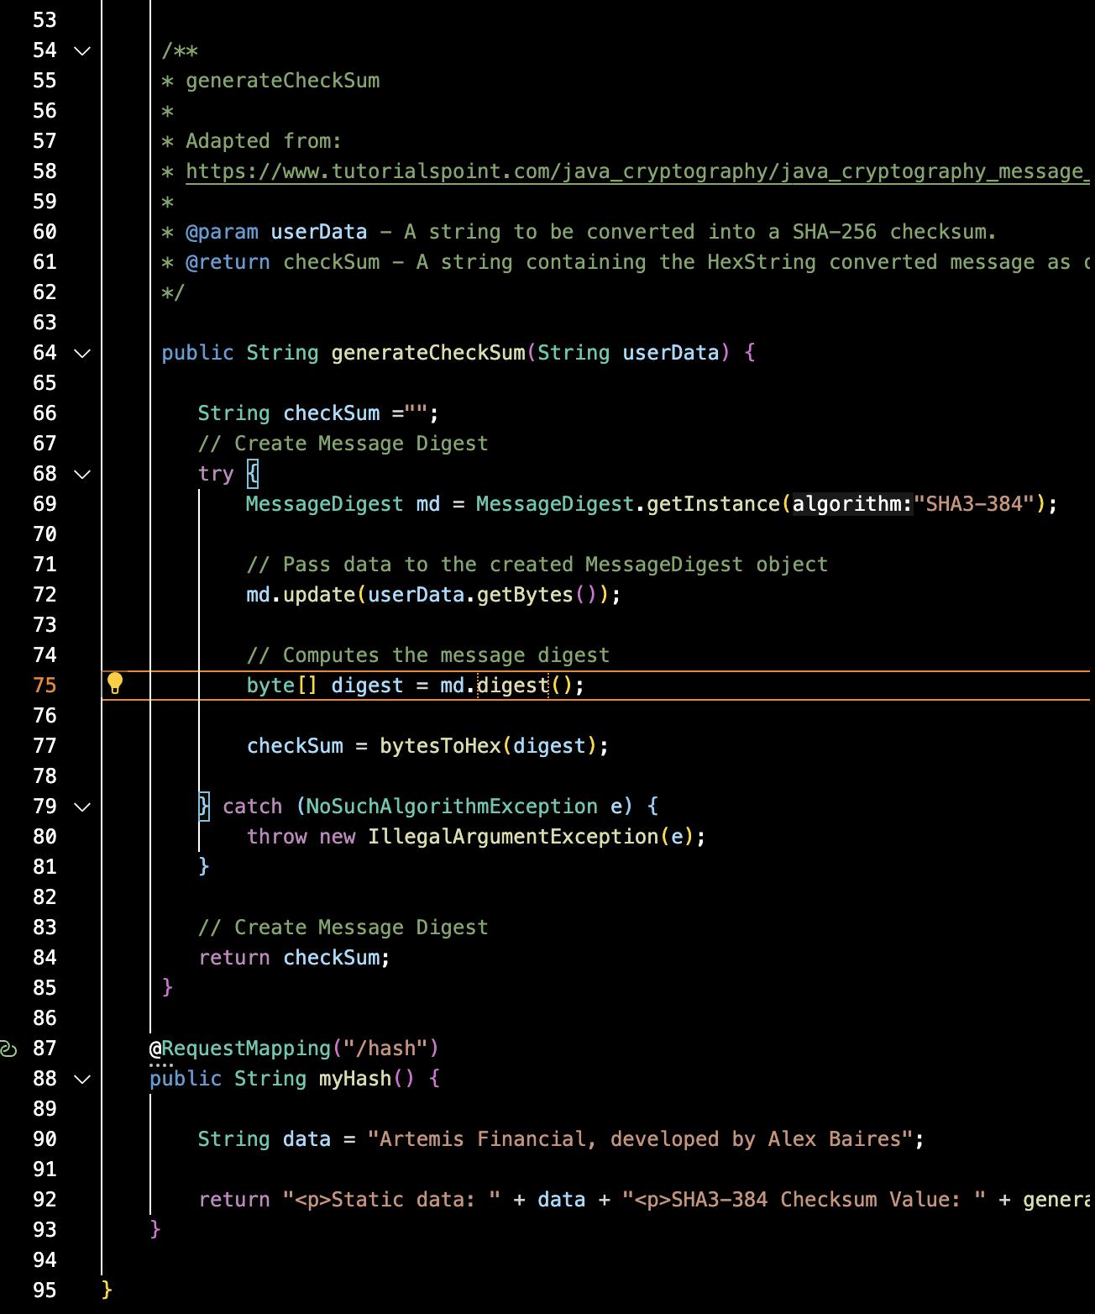

Initial pom.xml (the red highlight is a vulnerability detected by VS Code’s Red Hat Dependency Analyzer), pom.xml was also updated with the latest 9.2.0 OWASP Dependency Check.

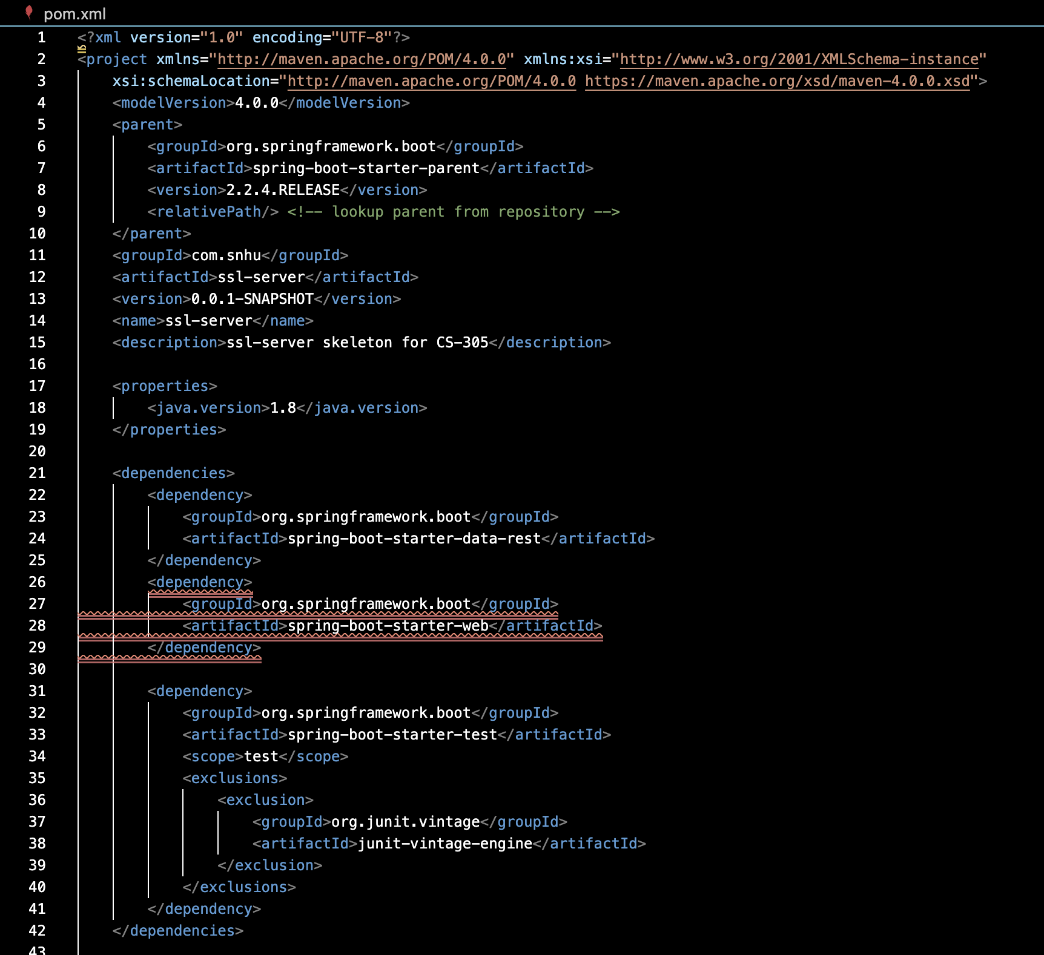

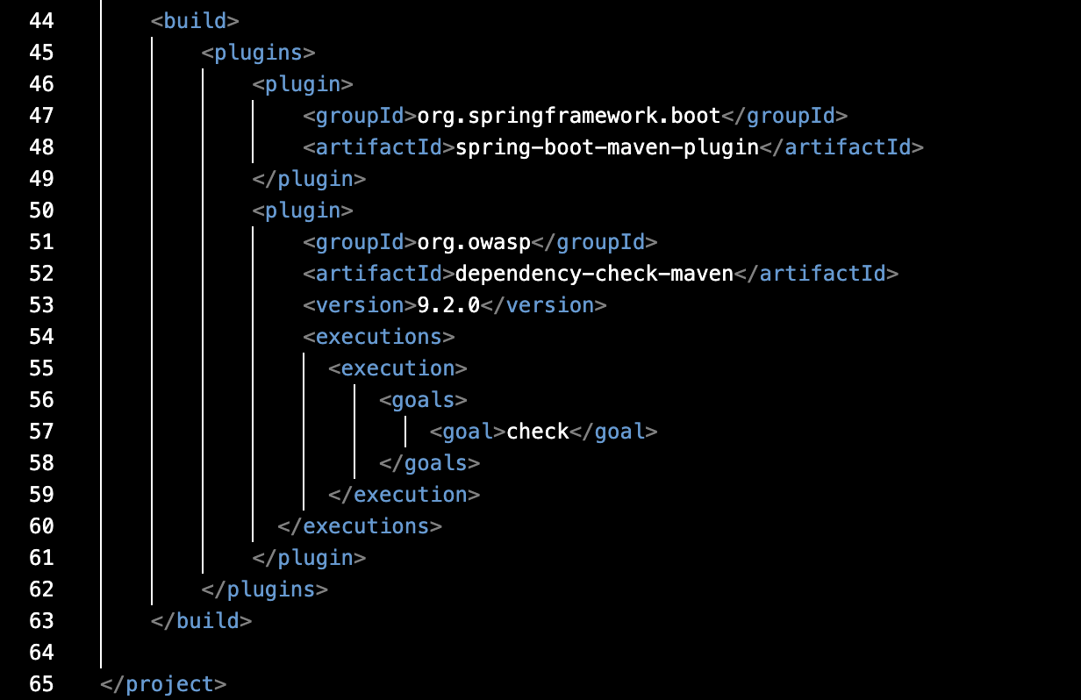

Refactored SslServerApplication.java Running in Terminal:

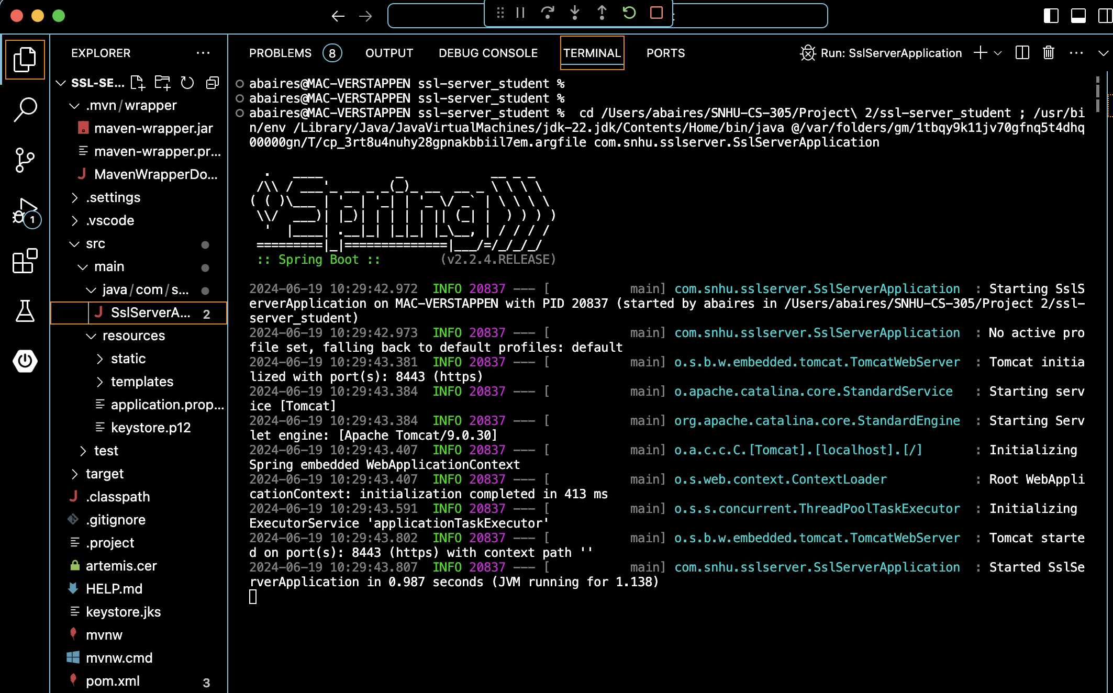

Initial Dependency-Check:

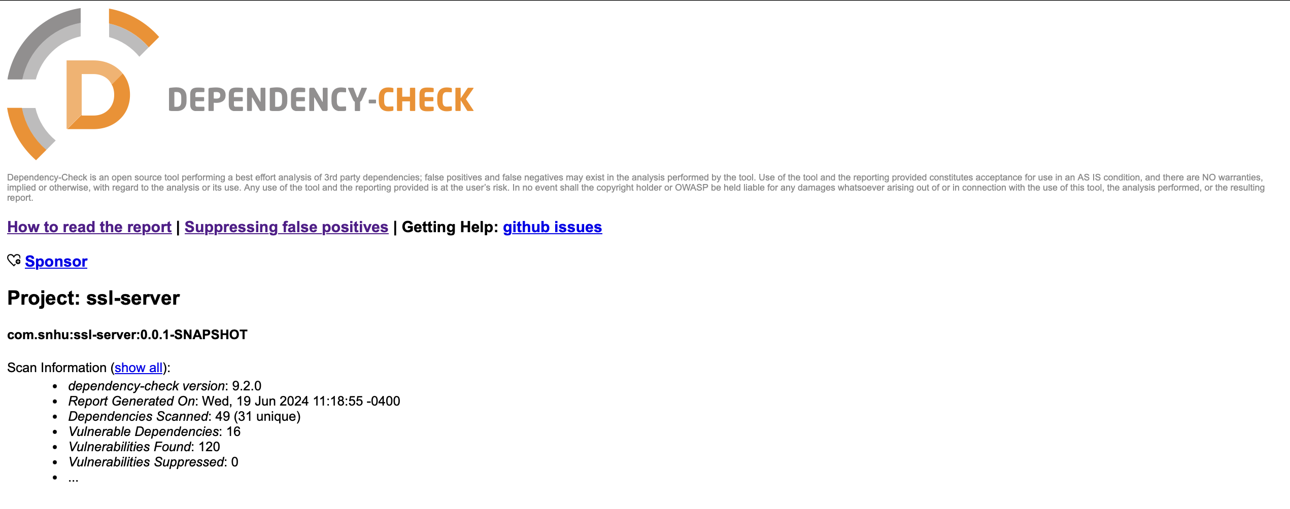

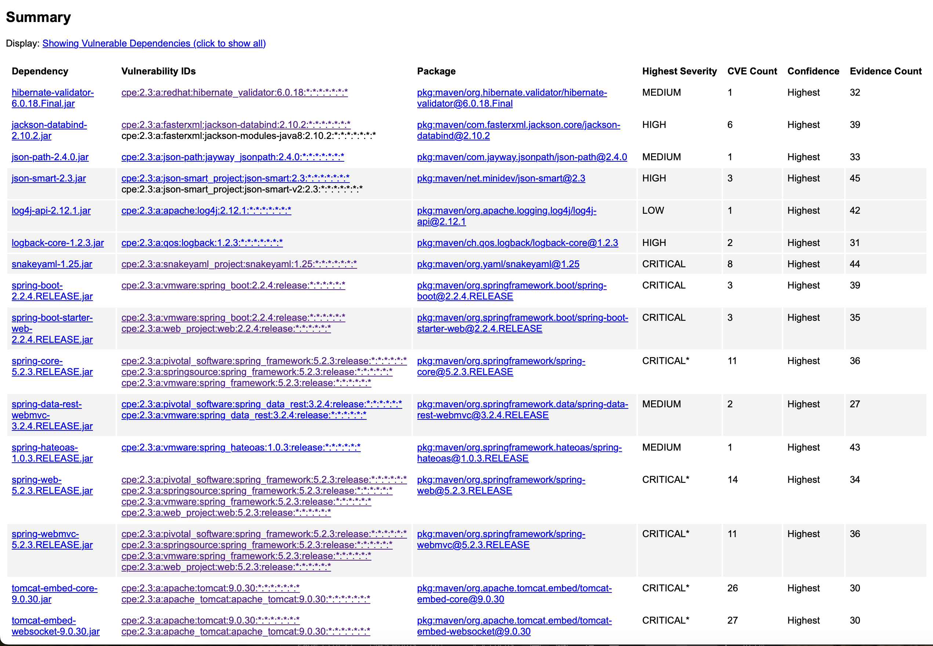

mvn dependency:tree command – Shows all dependencies in the project

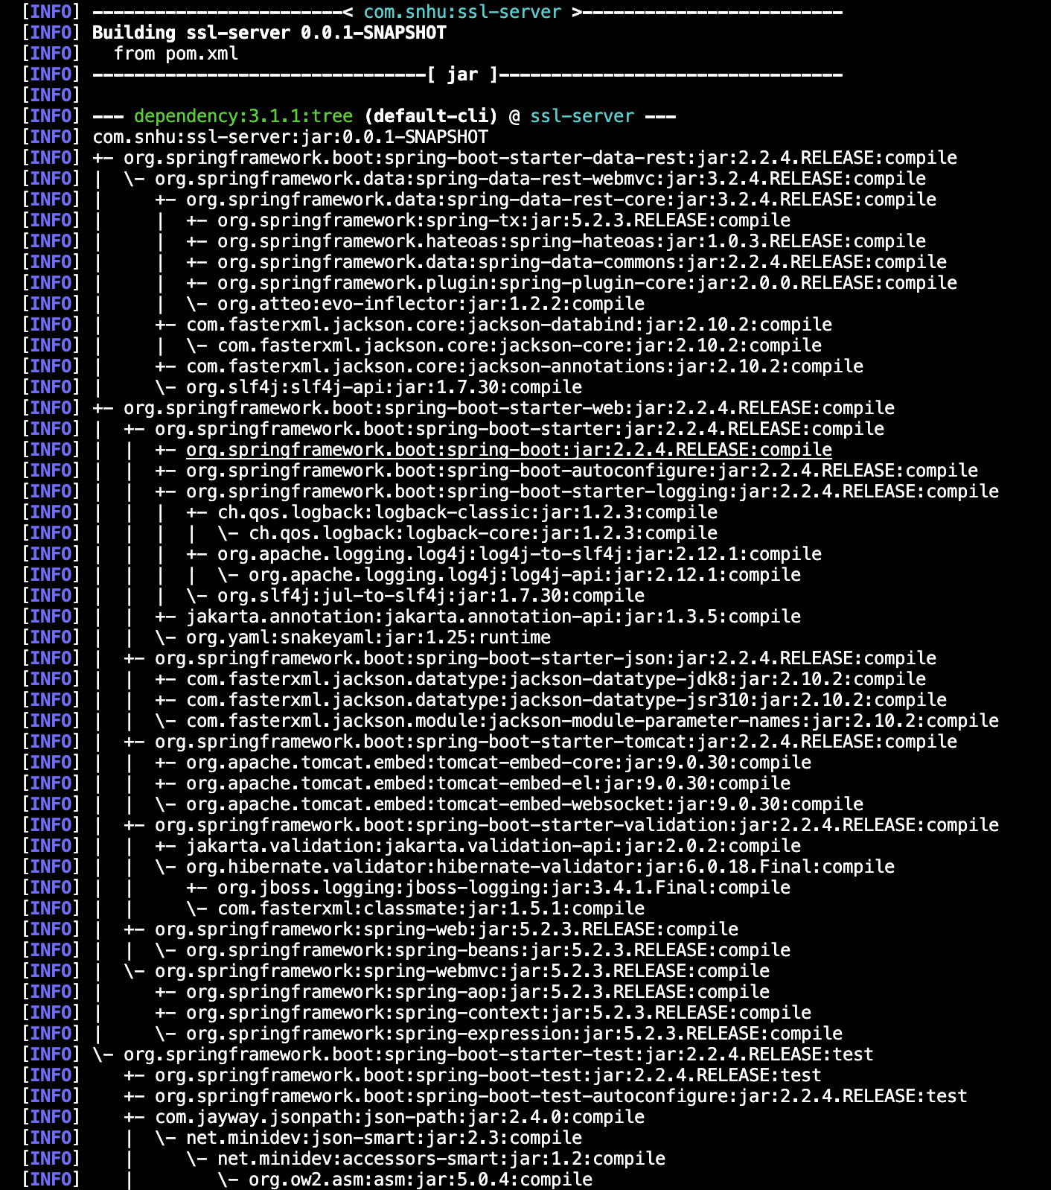

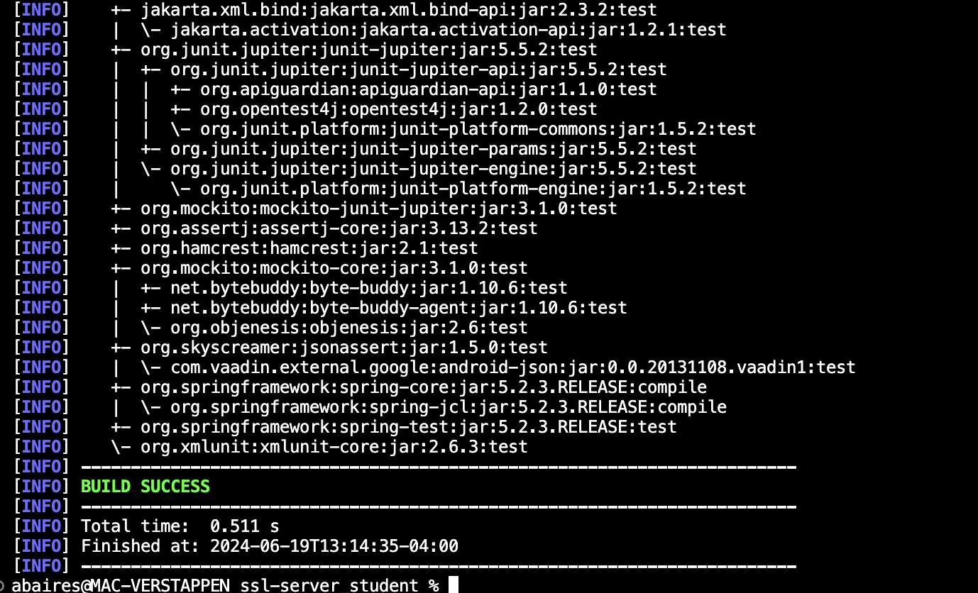

mvn versions:display-dependency-updates command – Shows all available updates to dependencies (truncated screenshot)

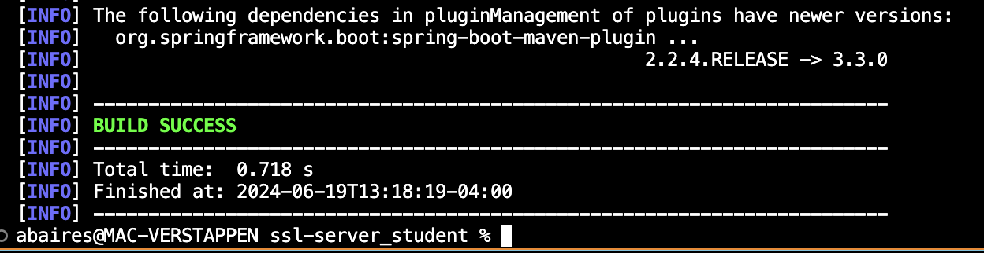

Updated to version 3.0.13 because this is the latest Spring Boot version that supports Java 1.8.

Reran Dependency-Check with Spring Boot 3.0.13:

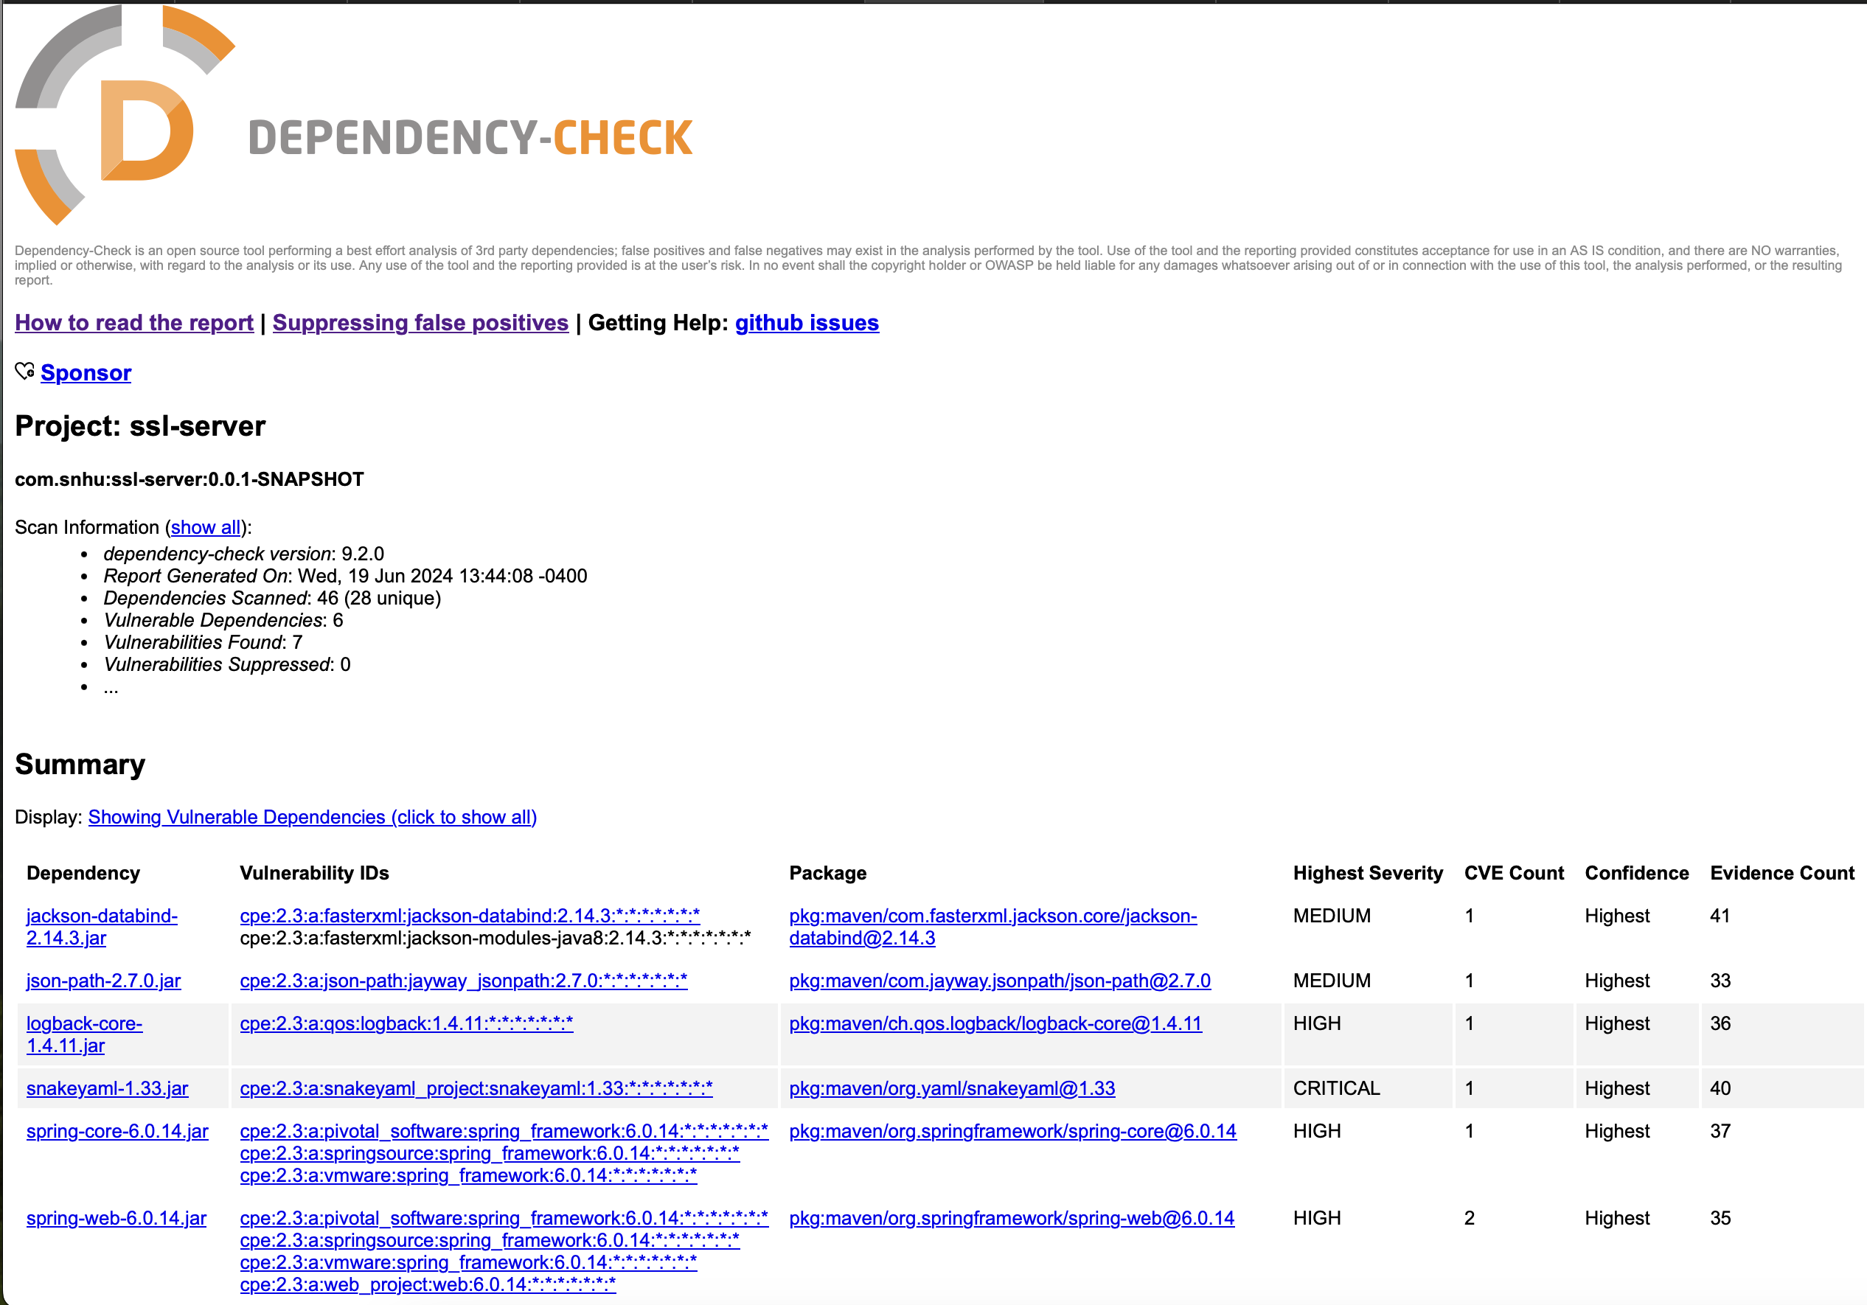

Added <DependencyManagement> section to pom.xml to have Spring call for specific sub-dependencies such as Jackson-databind, json-path, logback-core, logback-classic, snakeyaml, spring-core, spring-web. These dependencies were found by cross-referencing the dependency-check vulnerabilities with MVNRepository.

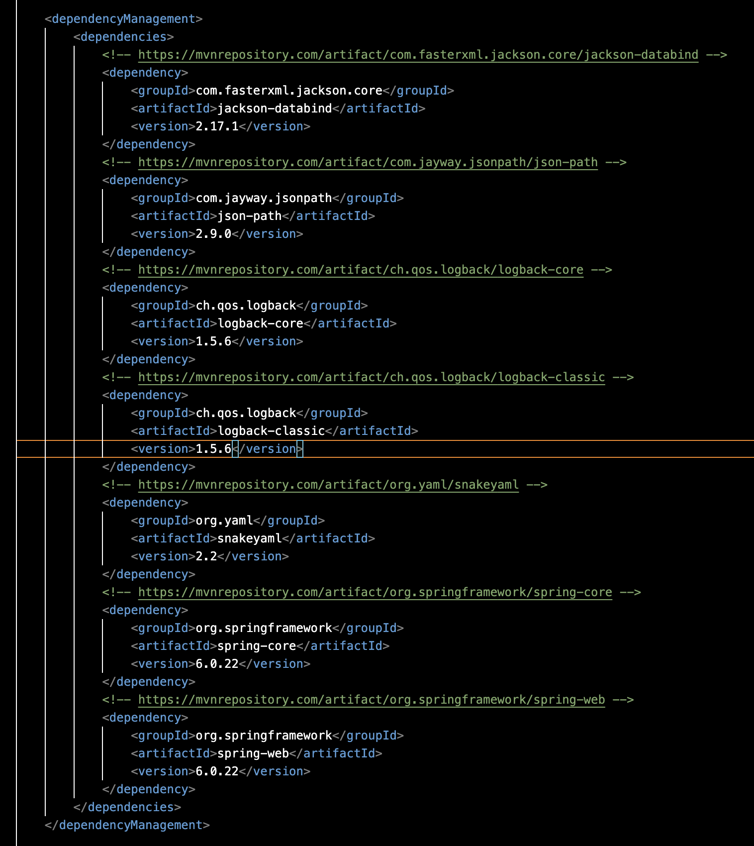

Updated Dependency-Check HTML showing 0 vulnerabilities after updating all dependencies:

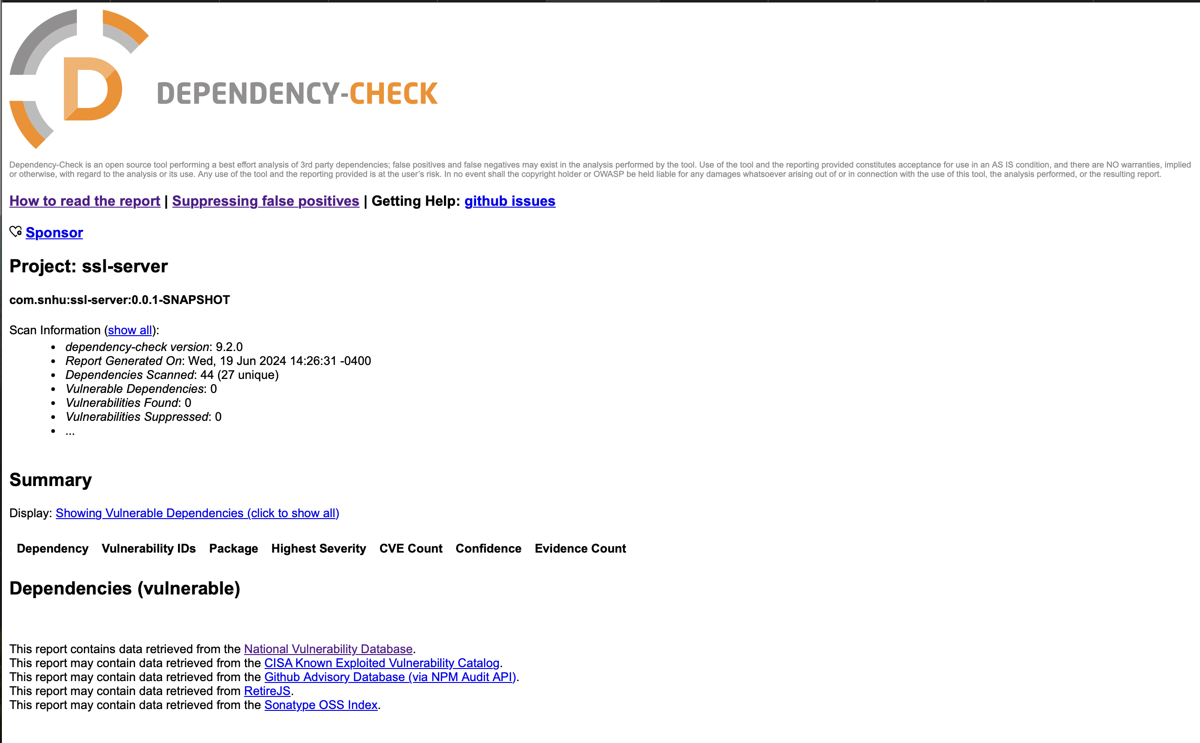

Refactored SslServerApplication.java with updated dependencies running in Terminal:

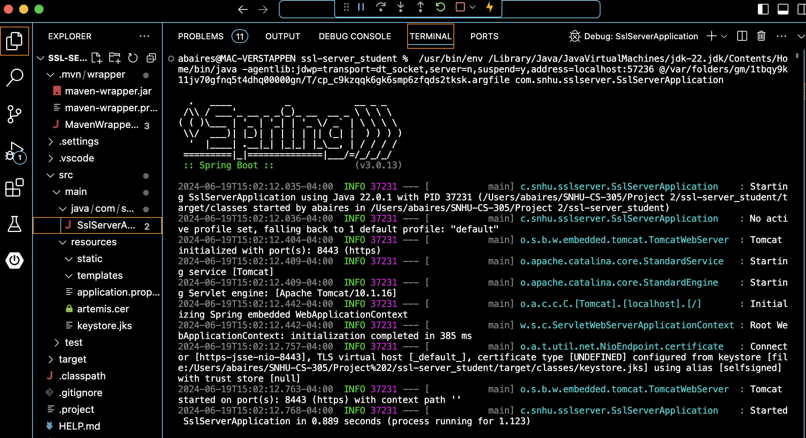

NOTE: After refactoring the code for secure error handling by adding MyErrorController.java and using Thymeleaf, Dependency-Check found a new vulnerability in the program:

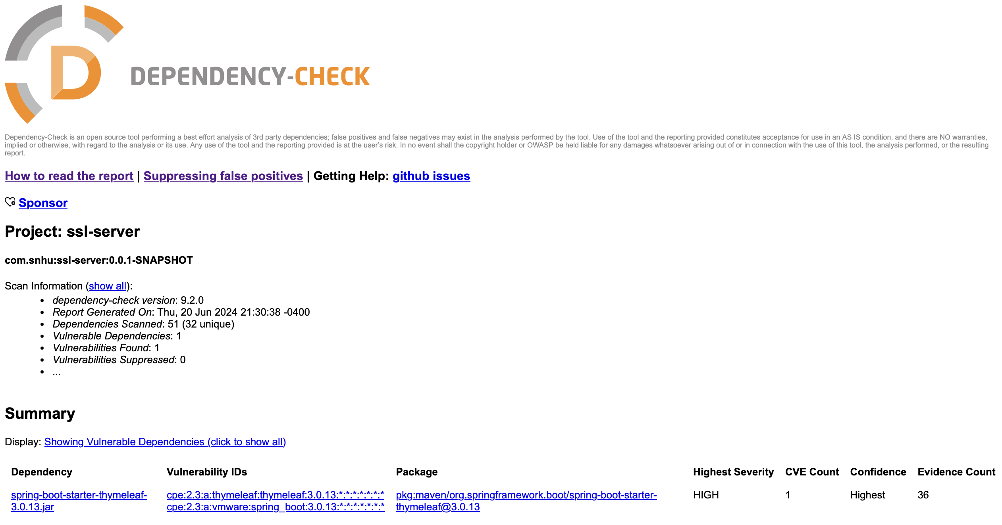

I

pom.xml was updated with the latest Spring-Boot-Starter-Thymeleaf version 3.3.0:

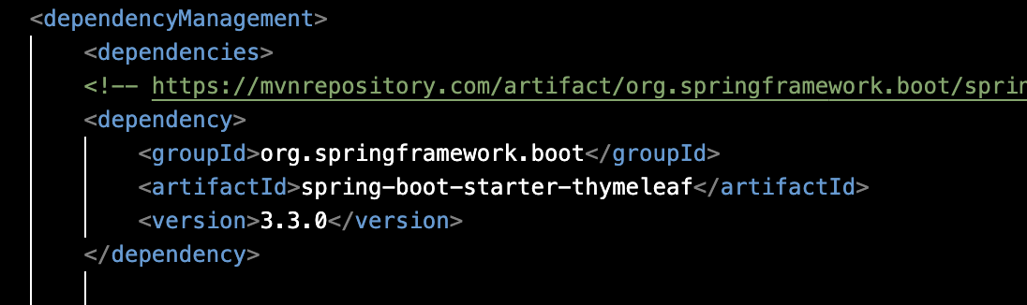

Dependency-Check was run once more, showing no vulnerabilities:

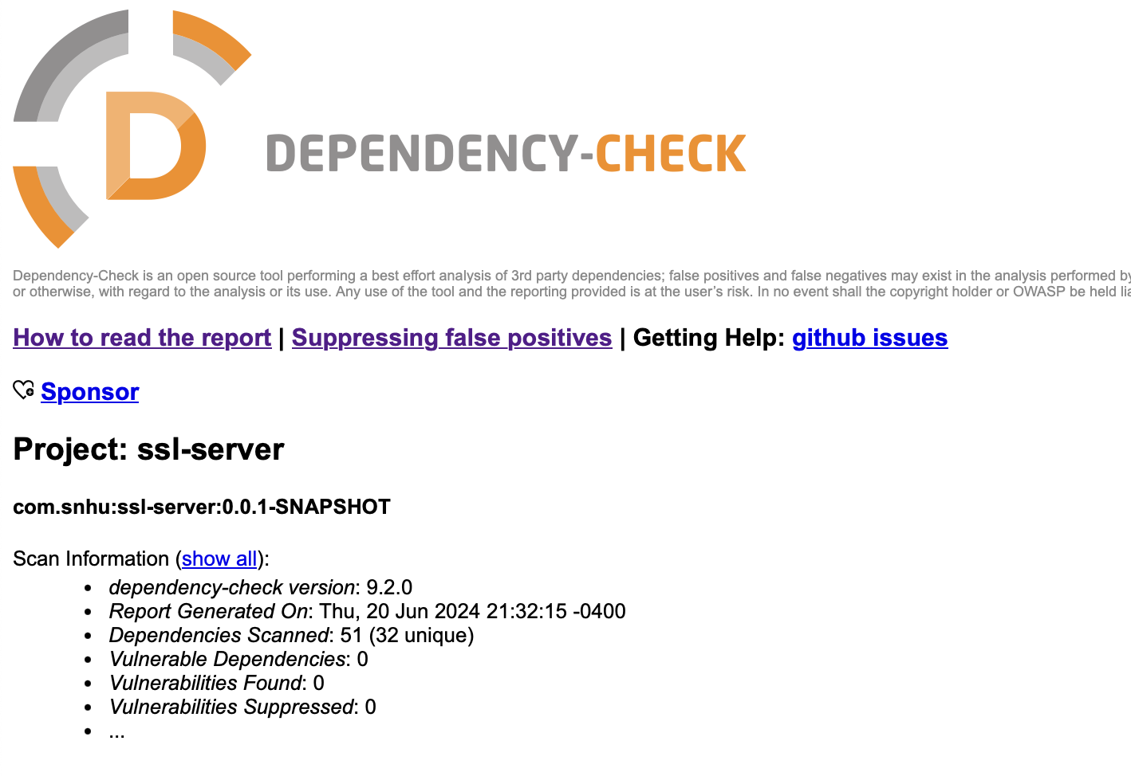

## Functional Testing

Insert a screenshot below of the refactored code executed without errors.

Refactored SslServerApplication.java:

Implemented a logger, used StringBuilder with String.format to prevent insecurities with toHexString().

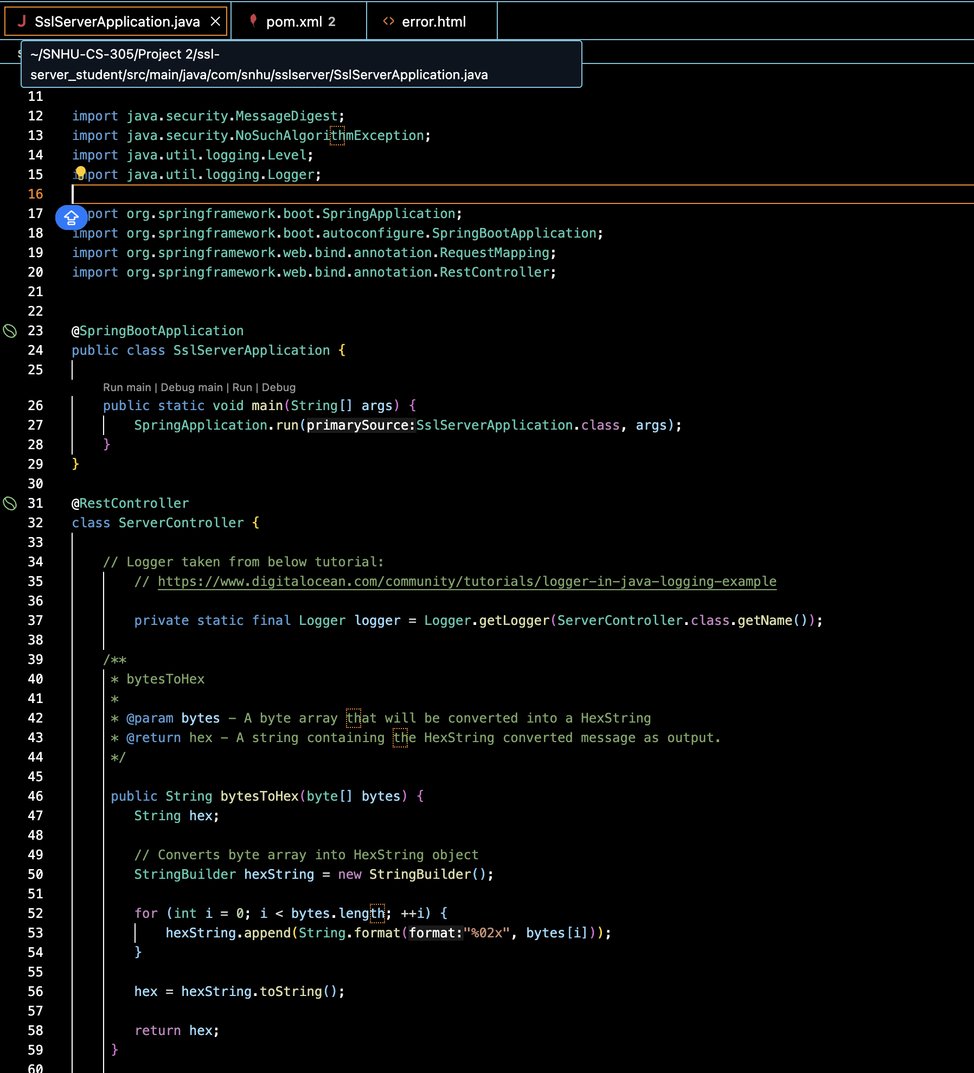

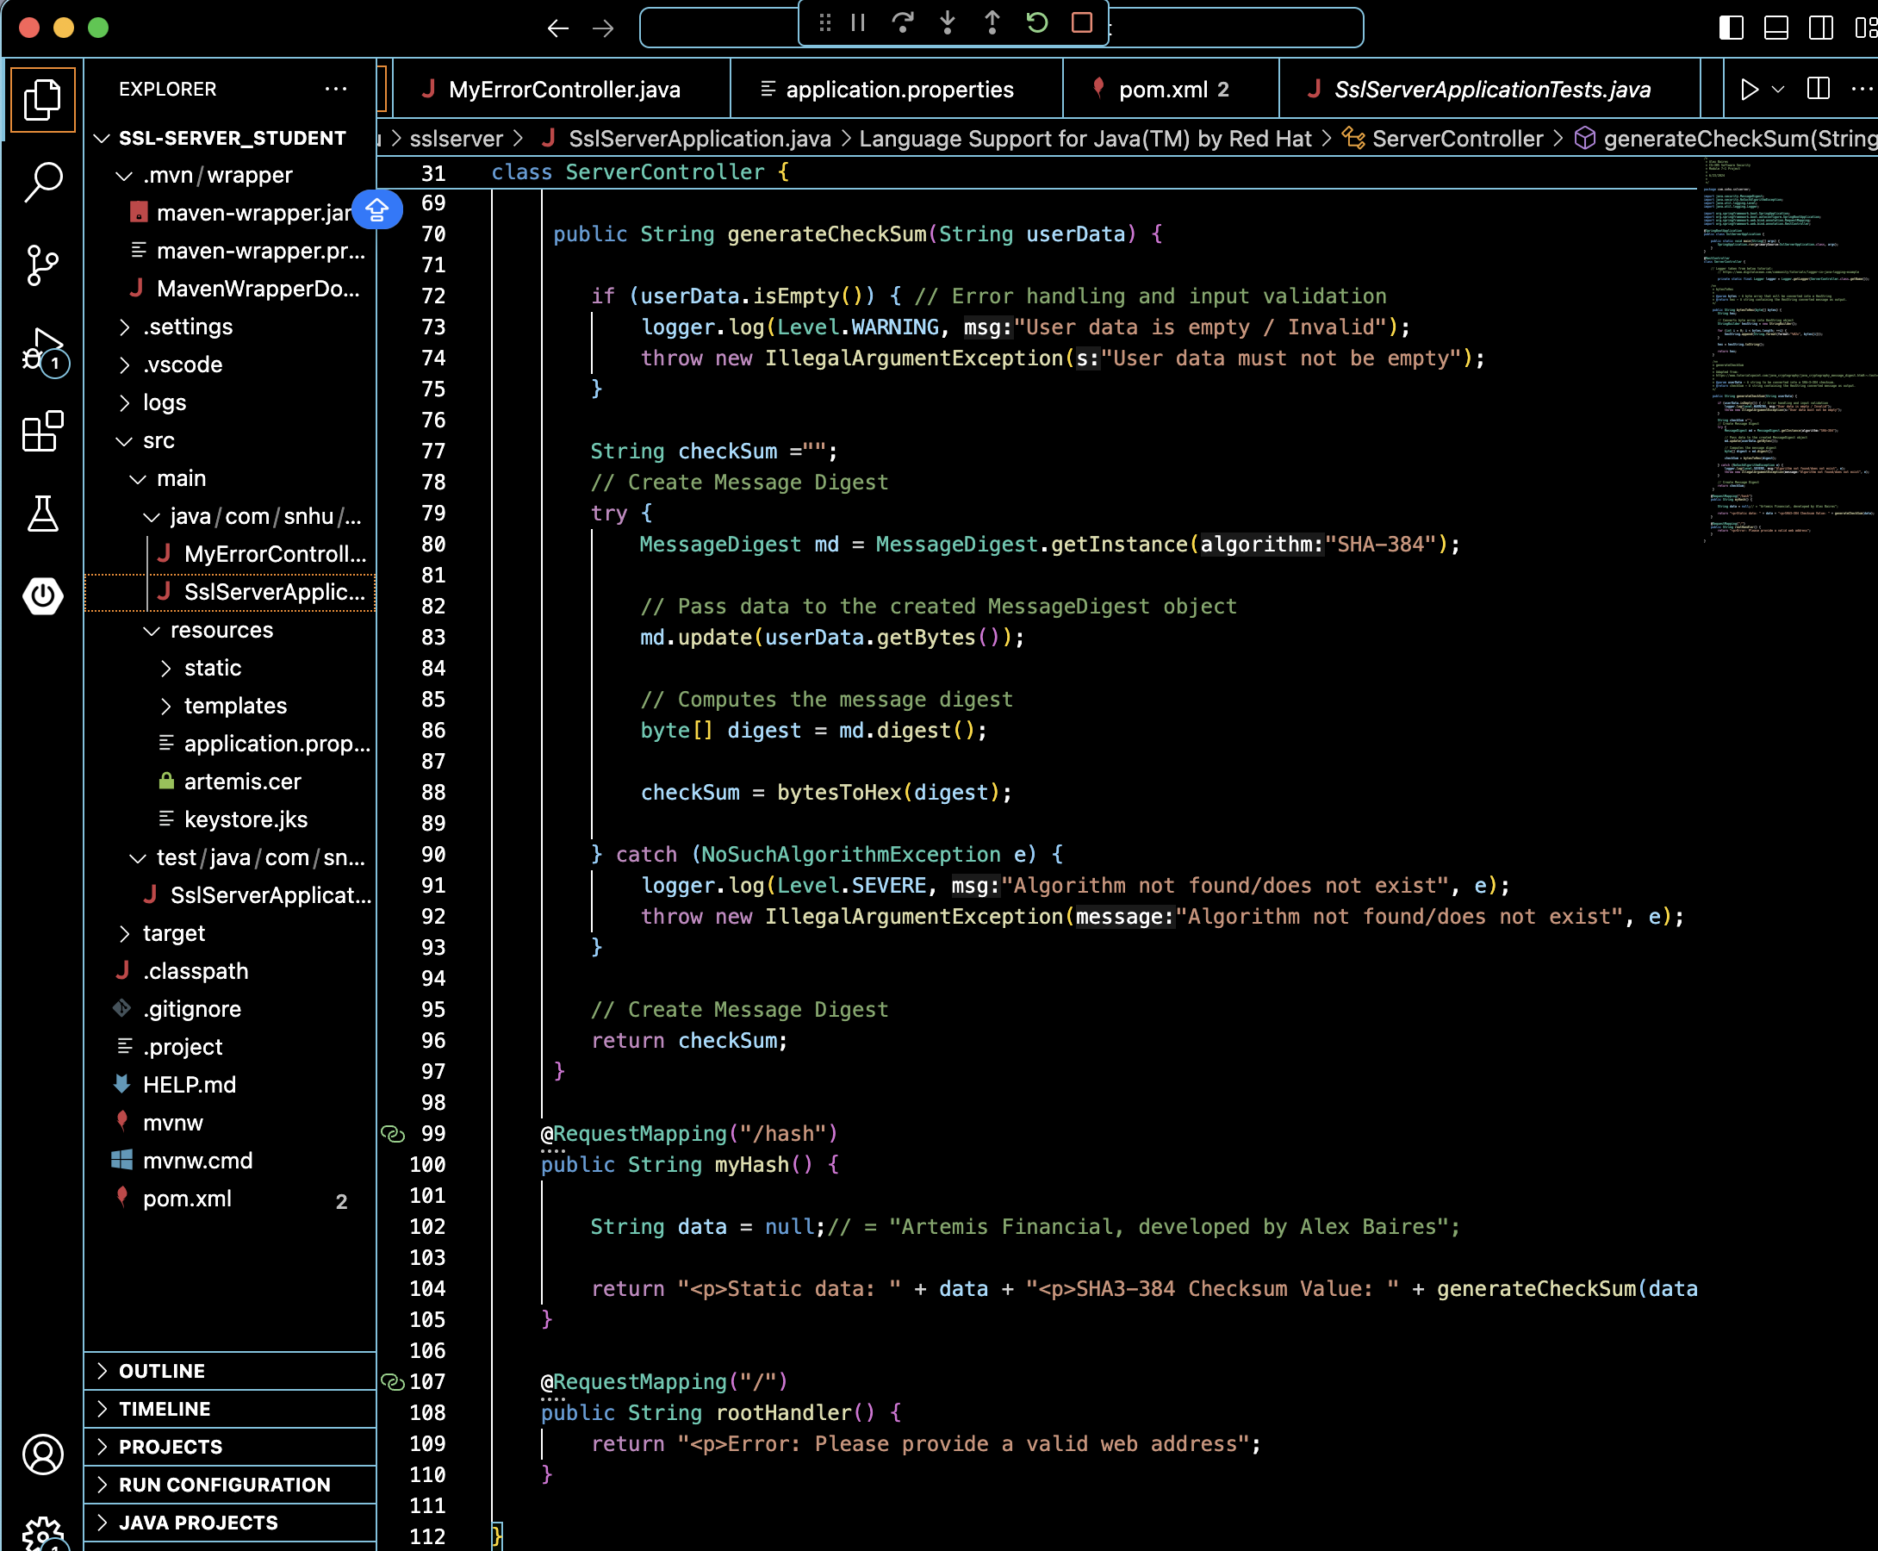

Updated pom.xml to use the latest version of the Thymeleaf dependency, a server-side Java template engine:

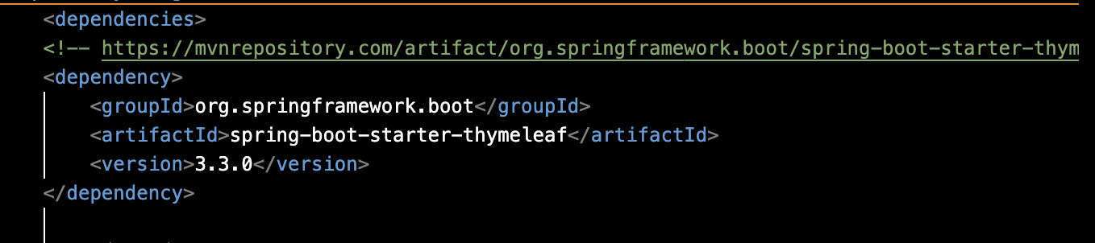

Added MyErrorController.java to display a webpage with an error message if an exception is thrown or the user attempts to access an unmapped path:

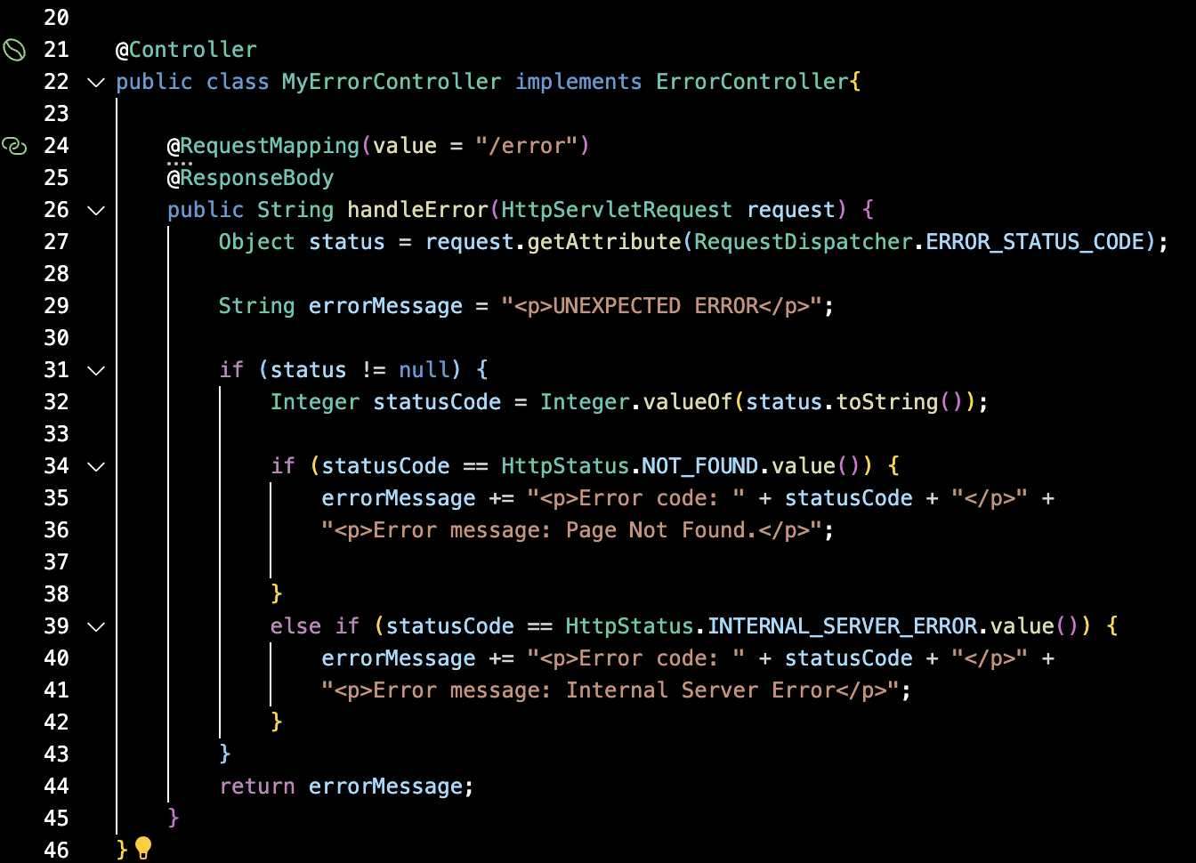

FINAL SslServerApplication.java running without errors:

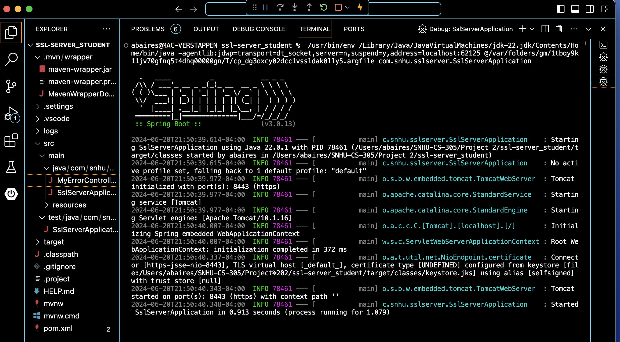

## Summary

The first step in the vulnerability assessment process is the architectural review. Initially, SslServerApplication.java was a Spring Boot application without an API or error handling classes. To make the application a RESTful web service for transmitting data between client and server, a REST controller with a ServerController class was implemented. Using REST ensures that the program satisfies the “Secure API Interactions” area of security because it is easy to implement HTTPS with Transport Layer Security (TLS). HTTPS with TLS uses signed digital certificates to authenticate clients and servers, enabling encryption. Each endpoint communicates through TLS handshakes to validate both identities and ensure secure data exchanges.

Configuration for HTTPS with TLS was enabled in the application.properties file by specifying server port 8443 for HTTPS and using a Java KeyStore (JKS) file to store the server’s private keys. A self-signed certificate (artemis.cer) was created to simulate a Certificate Authority (CA); Artemis will have its own issuer, eliminating the browser “insecure connection” warning. This certificate contains the public key, server name, and identifying information for clients to validate before establishing a connection. Verifying identities and encrypting traffic satisfies the “Client / Server” area of security.

Artemis Financial seeks to verify file data integrity through a checksum. In the final product, a user can download their statement and compare its checksum to the one displayed on the web portal to the database. To satisfy the “Cryptography” area of security, this checksum will be generated by the SHA-3-384 algorithm implemented by the MessageDigest class. The file contents are passed to the MessageDigest object and computed through the SHA-3-384 algorithm with the encrypted data in byte form. The bytesToHex function converts the data into a HexString object and converts it into a string that can be displayed on the web portal.

For the “Code Quality” area of security, the application follows secure coding practices by handling exceptions properly inside the generateChecksum function. If the user data is empty, a warning is logged to a file to alert the administrator, and an illegal argument exception is thrown stating that the data must not be empty. The bytesToHex function initially used StringBuffer to build the HexString but was replaced with StringBuilder for speed.

The “Input Validation” area of security is handled by the @RequestMapping annotation. Initially, a user who attempts to access the root <https://localhost:8443> was able to see other HTTP mappings:

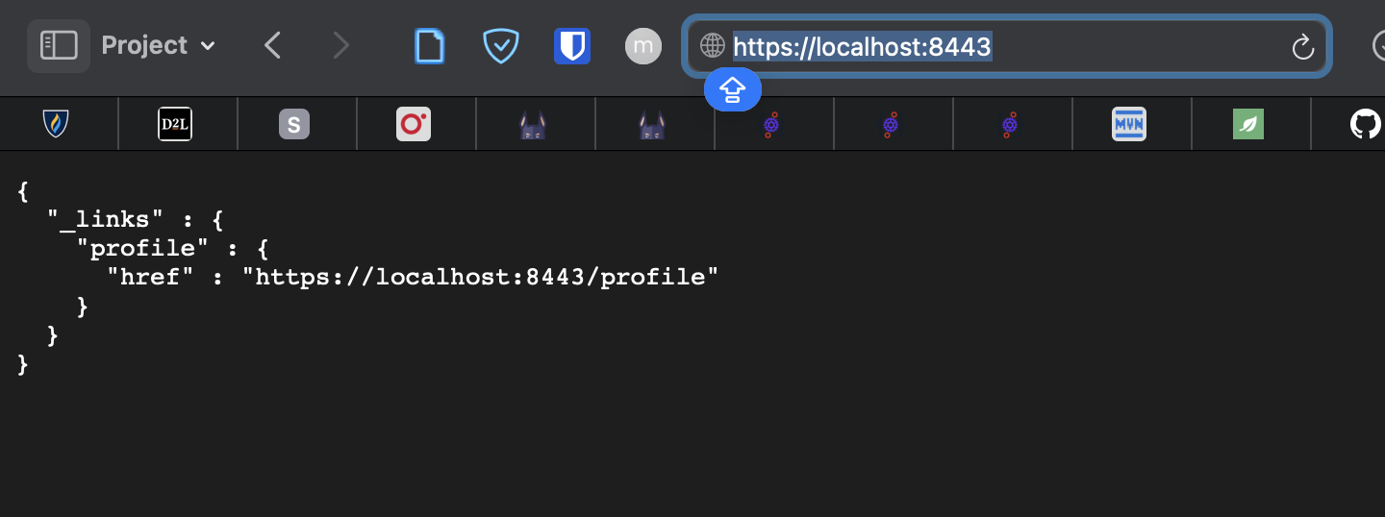

However, adding a rootHandler function replaced the above vulnerability with a generic web page that displays an error message. When Artemis Financial uses this application to verify files, we must implement an input validation function that specifies a character limit and eliminates special characters to sanitize the input.

Finally, this application satisfies the “Code Error” area of security because it has secure error handling through the MyErrorController class. This contains a URL mapping for “/error” that takes a resulting HTTP error, displays the code, and provides a message on the web page's body. Any invalid mappings will trigger an internal server error, minimizing the ability of a hacker to guess an insecure URL. Furthermore, obfuscating the error’s stack trace will prevent an attacker from knowing the specific libraries and languages being used in the application.

The next step in the security process is to run a Dependency-Check. The initial report had 135 vulnerabilities, most of which were resolved by updating Spring-Boot to version 3.0.13. This would have been updated to the latest Spring-Boot 3.3.0, but it does not support Java 1.8. Artemis Financial has yet to specify whether all of its devices are compatible with Java 22, so 3.0.13 was selected because it was the last version to support Java 1.8. A <dependencyManagement> section was added to pom.xml. This tells the Maven installer to override and use these specific sub-dependencies despite the parent Spring Boot dependency version. By upgrading all dependencies and testing the application, we eliminated all vulnerabilities. However, implementing the MyErrorController class used Thymeleaf, which introduced a new vulnerability. This was also eliminated by adding the latest Thymeleaf dependency to the dependency manager, illustrating the importance of running a Dependency-Check for every new dependency added.

## Industry Standard Best Practices

The application was written with the *OWASP Secure Coding Practices Quick Reference Guide* checklists as guidelines. All data validation is conducted server-side in SslServerApplication.java. For example, the application ensures that user data is not empty and throws an exception if there is an input error. Sensitive information, like the data string, is encrypted through the SHA-3-384 algorithm to implement satisfactory encryption for stored data. In the final version, the algorithm implementation will be used as a checksum to verify the integrity of the data to prevent errors or tampering.

Additionally, per OWASP guidelines, verbose error messages have been turned off, particularly if the user attempts to access a broken or non-existent link. The user is led to a web page with a generic error, while the error is logged on the server with more detail for administrators to research. Per best practices, the application performs error handling through try/catch/throw statements and uses input validation to prevent buffer overflow attacks. Using the OWASP Dependency-Check suite to check dependencies satisfies the OWASP recommendation that all servers, frameworks, and system components be patched. Artemis Financial is currently using Java SE 8, and the team used MVN Repository to patch dependencies to the appropriate compatible versions. We recommend that Artemis Financial upgrade its software to the latest Java 22 implementation because the latest versions of Spring do not support Java SE 8, which could introduce further vulnerabilities in the future, especially if Oracle stops supporting this flavor of Java.

According to OWASP, it is more economical for a company to initially apply secure coding industry standard best practices to design a secure, robust platform that manages consumer data than to correct it in a completed application. It is significantly more expensive to suffer a data breach (ask Equifax, which paid $425 million in settlements after exposing personal data) (*Equifax Data Breach Settlement*, 2022). Additionally, constantly fixing vulnerabilities can be exorbitant for a company's bottom line. Furthermore, as an American company, Artemis Financial must comply with the Gramm-Leach-Billey Act (GLBA) and the Sarbanes-Oxley Act (SOX) while ensuring compliance with the Federal Financial Institutions Examination Council’s (FFIEC) guidelines on cybersecurity. The GLBA states that all financial institutions must take measures to protect consumer data from cyberattacks that can leak or manipulate personal information stored in their databases, which is why the checksum validation implementation was essential to this project. Regarding SOX, it was initially developed to protect investors from scams while maintaining accurate financial records but has grown to regulate the adoption of standard cybersecurity measures by these institutions to prevent the interception of secure communications through phishing or the disruption of communications through denial-of-service attacks (DDoS). (Kost, 2024; Kost, 2024a).

**References**

Akiya, Y., Le, K. T., Luong, M., Wilson, J. C., Eddin, A. S., Formicola, V., & El-Hadedy, M. (2021). *SHA-3-LPHP: Hardware Acceleration of SHA-3 for Low-Power High-Performance Systems*. 2021 IEEE International Symposium on Software Reliability Engineering Workshops (ISSREW), Software Reliability Engineering Workshops (ISSREW), 2021 IEEE International Symposium on, ISSREW, 393–398. https://doi-org.ezproxy.snhu.edu/10.1109/ISSREW53611.2021.00107

Anand, A. (2021, December 12). *Breaking down : SHA-3 Algorithm - InfoSec write-ups.* Medium. https://infosecwriteups.com/breaking-down-sha-3-algorithm-70fe25e125b6

*Cryptography Concepts*. (2024, May 7). IBM I. Retrieved June 18, 2024, from https://www.ibm.com/docs/en/i/7.5?topic=cryptography-concepts

*CS-305 Vulnerability Assessment Process Flow* (n.d.).

*Equifax Data breach settlement*. (2022, December 20). Federal Trade Commission. https://www.ftc.gov/enforcement/refunds/equifax-data-breach-settlement

Grimes, R. (2018, February 21). *Why aren’t we using SHA-3?* CSO Online. https://www.csoonline.com/article/564619/why-arent-we-using-sha3.html

Huang, S., Agmon Ben-Yehuda, O., Dunkelman, O., & Maximov, A. (2022, September 9). *Finding collisions against 4-round SHA3-384 in practical time.* https://eprint.iacr.org/2022/194.pdf.

Kost, E. (2024, May 21). *Top 9 cybersecurity regulations for financial services | UpGuard.* Retrieved June 18, 2024, from https://www.upguard.com/blog/cybersecurity-regulations-financial-industry

Kost, E. (2024a, April 25). *The 6 biggest cyber threats for financial services in 2024 | UpGuard.* Retrieved June 18, 2024, from https://www.upguard.com/blog/biggest-cyber-threats-for-financial-services

Manico, J., & Detlefsen, A. (2014). *Iron-Clad Java: Building secure web Applications.* Oracle Press. http://dl.acm.org/citation.cfm?id=2826076

*OWASP secure coding practices—quick reference guide | Secure coding practices | OWASP foundation.* (n.d.). Retrieved May 7, 2024, from https://owasp.org/www-project-secure-coding-practices-quick-reference-guide/stable-en/02-checklist/05-checklist.html

Sidhpurwala, H. (2019, June 5). Understanding random number generators, and their limitations, in Linux. *Red Hat Blog*. Retrieved June 18, 2024, from https://www.redhat.com/en/blog/understanding-random-number-generators-and-their-limitations-linux